Title Should be Brief and Descriptive in Arial 11pt Bold, Single Spaced, and Centered. The Reccomended Length of the Title is no more than 2 Lines.
First Author¹*, Second Author², Third Author³, Second Author^{n}
(1)Institution, Address, Town, Country, *email@address of the presenter
(2)Institution, Address, Town, Country
(3)Institution, Address, Town, Country
(n)Institution, Address, Town, Country

Preference for poster presentation: YES / NO

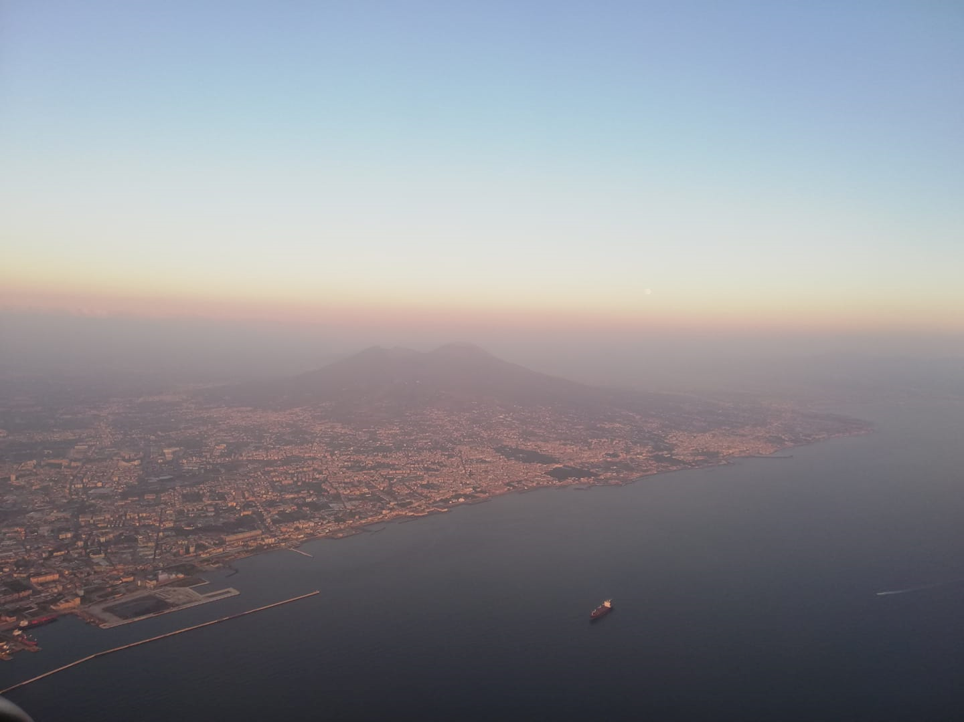
The Figure caption (Arial 9 pt, italics) should follow straight after the Figure, centered, without any line between the Figure and its caption.

Preparation and Submission of the Abstracts
This document is designed to assist authors in preparing their submission. We strongly recommend to type the abstract over this template in order to ensure that all contributions have the same style with a view to creating a final Book of Abstracts.
The Abstract should contain one picture representing the study area, located right after the Title and the Authors’ names and Affiliations.
All authors’ names, including full first names (no initials) and last names, must be in Arial 10pt Italic, single spaced, and centered. Indicate each author’s Affiliation with a number in parentheses immediately in front of the Institution’s name.The presenting author’s name should be indicated with an asterisk (*) and the e-mail address mentioned toghether with the affiliation(s).
The Abstract should not exceed 300 words and the file should not be longer than 2 pages (including possible references). The text of the body of the Abstract should be single column, in Arial 11 pt, justified.
Rename the final file as ‘Author_NEPTUNE2022.doc[docx]’, where Author is the corresponding author’s name. Abstracts should be submitted (as an attached Microsoft Word document in .doc or .docx) via email to gaia.mattei@uniparthenope.it and/or claudia.caporizzo@uniparthenope.it by May 30, 2022.
The authors can express their preference for a poster presentation by using the appropriet section located in the upper part of this format (after author’s Affiliation).
The abstracts will be reviewed by members of the Scientific and organizing Committee of the 3rd INTERNATIONAL NEPTUNE WORKSHOP and notifications of acceptance status will be sent by June 30, 2022.

References
[Journal Article] Author, A.A., Author, B.B., and Author, C.C., YEAR. Title of Journal Article. Title of Journal, volume number (issue number) [x(x)], page numbers [pp. xxx-xxx]. https://doi.org/xx.xxxxx.
[Book] Author, A.A., Author, B.B., and Author, C.C., YEAR. Title of Book. Edition, Publisher: Place of publication; Total number of pages [p. xxx].
[Book chapter] Author, A.A., Author, B.B., and Author, C.C., YEAR. Title of the Book Chapter. In: Editor, A.A., Editor, B.B., and Editor, C.C. (Eds.), Title of the Book, page numbers [pp. xxx-xxx].
[Conference Proceedings] Author, A.A., Author, B.B., and Author, C.C., YEAR. Title of the proceeding. Title of the Conference, City, Country, Date of the Conference.

